Inprism
The game brining light to a new world.

- Learn scientific concepts in a visual way.
- Overcome puzzles with logical thought processes.
- Change the game world around you as you play.
- Gain an intuitive understanding of how light behaves.
- Have fun as you learn

Serious Purpose
Players will gain an intuitive understanding of the way light reacts with the world around us.

Using this knowledge to solve puzzles, the player experiences a sense of accomplishment by overcoming obstacles and bringing colour to the game world.

Target Audience

For education purposes the game is designed for middle to high school students who are learning or have learned about the subject, but want to expand their learning in a fun way.
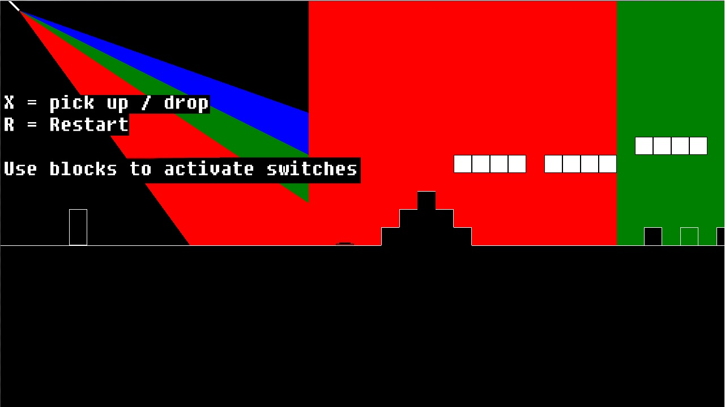
In game screenshot of tutorial level.

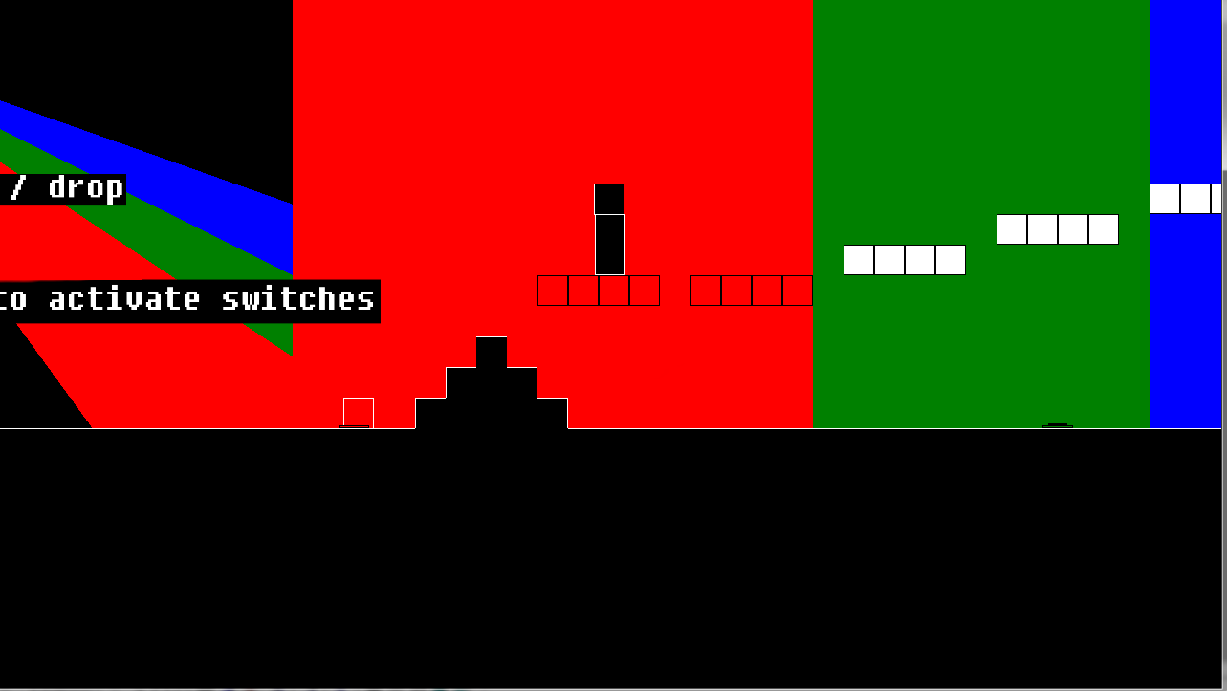
Example of how the game environment changes based on player interaction.

Thankyou for your attention, we hope you enjoyed our presentation.

Developed by Jesse Hughes, Blake Chapman and David Wallman.

